EE232 Exp. #1
Electronic Circuit Basics
Report #1

COURSE LECTURER:
Assistant Professor Dr. Fulya Kunter
LABORATORY INSTRUCTOR:
Research Assistant Deniz Özenli
Prepared by
Name:
Surname:
#ID:
CAUTIONARY REMARK: All questions will be answered in the assigned blanks. Don’t use extra place for the answers due to the fact that they are not guaranteed to be evaluated.
Part 1--Introduction: Explain the main objective of the first experiment on your own words. (10pt)

Part 2--Procedure: a) Resistor Color Coding: Explain the meaning of the color coding. Give an example from your experiment. (15pt)

b) Compare the calculated and measured resistance values during the lab. Is there big difference? If so, comment on reasons of that? (10pt)

c) Solve the following circuit using Node Analysis Method and KCL. Compare the measured values (during your experiment) and calculated values of the currents. (20pt)
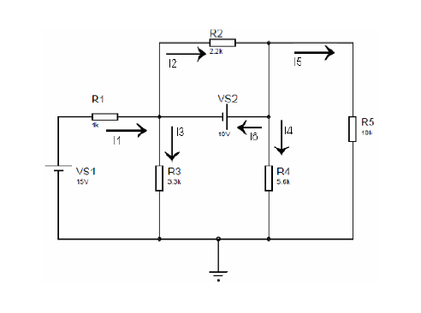

d) Solve the following circuit using Mesh Currents Method and KVL. Compare the measured values (during your experiment) and calculated values of the currents. (20pt)
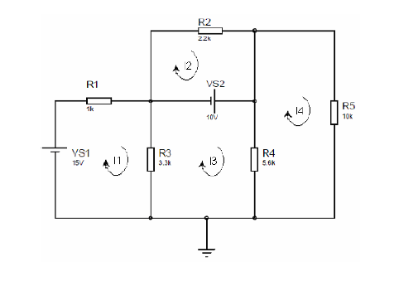

Part-3--Conclusion: Conclude your report with your learning from this experiment on your own words. Moreover, you can discuss or criticize some over-expected or under-expected sides of the experiment. (15pt)

Part-4--References: If you have referred parts, specify their references below. (10pt)

