EE311 Exp. #1
Diode Characteristics
Report #1

COURSE LECTURER:
Assistant Professor Dr. M.A.Alsunaidi
LABORATORY INSTRUCTOR:
Research Assistant Deniz Özenli
Prepared by
Name:
Surname:
#ID:
CAUTIONARY REMARK: All questions will be answered in the assigned blanks. Don’t use extra place for the answers due to the fact that they are not guaranteed to be evaluated.
Part 1--Introduction: Explain the main objective of the first experiment on your own words. (10pts)

Part 2--Procedure: a) Conventional Diode Basics: Describe $R_{DC}$ and $r_{AC}$ of conventional diode in mathematical expression. Comment on the meaning of those. (10pts)

b) Solve Figure.1 using linear diode model. Take as ${ r}_{d}=30Ω$ , $V_{on}=0.7V, R_{1}=2.2k and V_{SS}=17V$ (10pts)
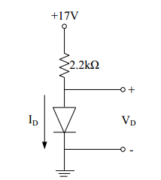
Figure.1

c) Plot $V_{SS}$ versus $I_{D}$and $V_{D}$ versus $I_{D}$ using your measurements during the lab by considering the Figure.2. (20pts)
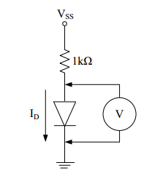
Figure.2

d) Plot $V_{SS}$ versus $I_{D}$and $V_{D}$ versus $I_{D}$ by using LT-Spice considering the Figure.2. Compare lab measurements and simulation results for Figure.2. If you have any differences, comment on them. (Important Note: Not use spice default libraries or models when you use diodes. You must utilize from a diode model presented in the appendix part.) (30 pts)

e) Research ‘zener diodes’ and solve the following circuit by taking as VS =20V, R2=1MΩ and D1 is zener diode whose Vz = 6V. (Hint: Vz is equal to zener voltage.) (15pts)
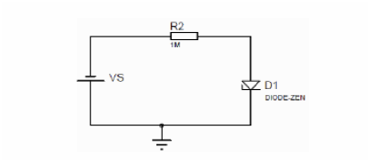

Part-3--Conclusion: Conclude your report with your learning from this experiment on your own words. Moreover, you can discuss or criticize some over-expected or under-expected sides of the experiment. (10pts)

Part-4--References: If you have referred parts, specify their references below. (5pts)

Part-5--Appendix:
You will use the following diode model for LT-Spice simulations:
.model Da1N4004 D (IS=18.8n RS=0 BV=400 IBV=5.00u CJO=30 M=0.333 N=2)

