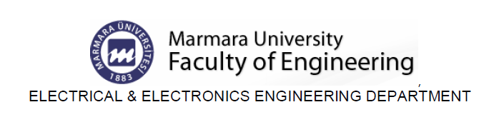

EE311 Exp. #2
Diode Clipping and Clamping Circuits
Report #2

COURSE LECTURER:
Assistant Professor Dr. M.A.Alsunaidi
LABORATORY INSTRUCTOR:
Research Assistant Deniz Özenli
Prepared by
Name:
Surname:
#ID:
CAUTIONARY REMARK: All questions will be answered in the assigned blanks. Don’t use extra place for the answers due to the fact that they are not guaranteed to be evaluated.
Part 1--Introduction: Explain the main objective of the first experiment on your own words. (10pts)

Part 2--Procedure: a) Motivation in Diodes: Explain the following concepts: (30pts)
a) Rise Time
b) Fall Time
c) Linear Diode Model
d) Pin Diode
e) Schotky Diode
f) Tunnel Diode
e) Varactor Diode

b) Sketch the shape of the output voltage waveform for the following ”clipper” circuits, assuming an ideal diode with no forward voltage drop:
(15pts)
i)
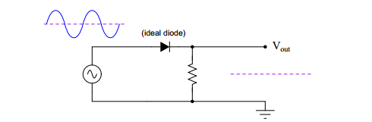
ii)
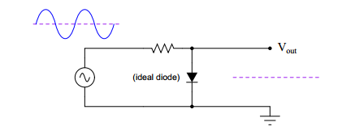

c) Design a clipper circuit that clips any portion of the input AC waveform below +3 volts:
(15pts)
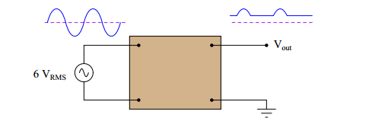
Figure.2

d) Plot Vo(t) of the following circuit. Which condition should be satisfied regarding C, r_{D} and R_{L} in order to avoid output waveform distortion? Is that condition satisfied in here? (C=0.1uF, R_{L}=100kΩ and r_{D} is equal to inner resistance of the ideal diode.) (25pts)
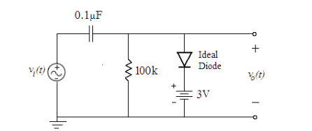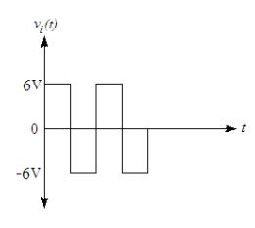
Figure.3

Part-3--Conclusion: Conclude your report with your learning from this experiment on your own words. Moreover, you can discuss or criticize some over-expected or under-expected sides of the experiment. (10pts)

Part-4--References: If you have referred parts, specify their references below. (5pts)

