EE311 Exp. #3
Transistor Biasing
Report #3

COURSE LECTURER:
Assistant Professor Dr. M.A.Alsunaidi
LABORATORY INSTRUCTOR:
Research Assistant Deniz Özenli
Prepared by
Name:
Surname:
#ID:
CAUTIONARY REMARK: All questions will be answered in the assigned blanks. Don’t use extra place for the answers due to the fact that they are not guaranteed to be evaluated.
Part 1--Introduction: Explain the main objective of the first experiment on your own words. (5pts)

Part 2--Procedure: a) Biasing: Why is the correct biasing required and so important for circuits which contains BJT. Which biasing technique as you seen in Experiment 2 is better than others? Why? Explain (15pts) b) What are the β, $h_{fe}$, $h_{FE}$? Why is the BJT an active component? (10pts)

b) Consider Figure.1 below. For Vcc=12V and RB, RC and RB1, RB2 values as you calculated during the experiment, obtain DC operating values of the BJT’s for each biasing configuration in the LT-Spice Simulation by considering BJT model in the appendix part. Compare Spice results with your measurement results. Comment on results. (20 pts)
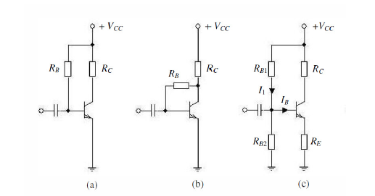
Figure. 1

c) AC gain: Plot AC gain of each configuration in Figure.1 using LT-Spice. Compare these results with your measurement results regarding AC gain. (Take input capacitance as 0.1uF.) (35pt)

Part-3--Conclusion: Conclude your report with your learning from this experiment on your own words. Moreover, you can discuss or criticize some over-expected or under-expected sides of the experiment. (10pt)

Part-4--References: If you have referred parts, specify their references below. (5pt)

Appendix:
BC237 BJT Model Parameters for Spice Simulation:
.MODEL BC237 NPN (IS=1.8E-14, ISE=5.0E-14, NF=0.9955, NE=1.46, BF=400, BR=35.5, IKF=0.14, IKR=0.03, ISC=1.72E-13, NC=1.27, NR=1.005, RB=0.56, RE=0.6, RC=0.25, VAF=80, VAR=12.5, CJE=13E-12, TF=0.64E-9, CJC=4E-12, TR=50.72E-9, VJC=0.54, MJC=0.33)

