EE311 Summer School Exp. #4
RC Coupled Transistor Circuits
Report #4

COURSE LECTURER:
Assistant Professor Dr. M.A.Alsunaidi
LABORATORY INSTRUCTOR:
Research Assistant Deniz Özenli
Prepared by
Name:
Surname:
#ID:
CAUTIONARY REMARK: All questions will be answered in the assigned blanks. Don’t use extra place for the answers due to the fact that they are not guaranteed to be evaluated.
Part 1--Introduction: Explain the main objective of the first experiment on your own words. (5pts)

Part 2--Procedure: a) Motivation in RC Coupled Transistor Circuits: Explain the following concepts: (20pts) (Hint: You can explain some issues by means of drawing as well.)
a) Bandwidth
b) Frequency Response
c) Corner frequencies
d) Amplitude and phase responses
e) Poles and zeroes.
f) High pass, low pass, band pass, notch and all pass filters
g) Common emitter configuration
h) Emitter follower configuration

b) Assume that T₁ and T₂ are equivalent BJT’s in the following circuit. Calculate I_{B}, I_{C} and I_{E} currents and V_{B}, V_{C} and V_{E} voltage drops of both transistor taking into account β =100, V_{BE}=0.7V, I₀=100mA, V_{CC}=15V R_{c}=100Ω. Calculate R_{i} and K_{v} (v_{c2}/v_{b1}) using hybrid-л model in the right below side. (Assume that r₀ is very high and V_{T}=25mV.) (25pts)
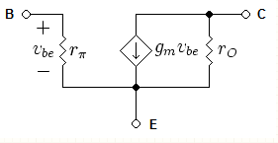
Figure.1

c) i) Calculate DC operating points in circuits below for β =100 and V_{BE}=0.7V. ii) Make AC analysis when S1 is closed and opened respectively. Calculate gains and input-output resistences. iii) Compare simulation results with measurement results during the lab. Explain differences. (35pts)
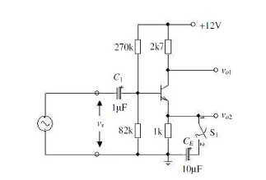
Figure.2

Part-3--Conclusion: Conclude your report with your learning from this experiment on your own words. Moreover, you can discuss or criticize some over-expected or under-expected sides of the experiment. (10pts)

Part-4--References: If you have referred parts, specify their references below. (5pts)

