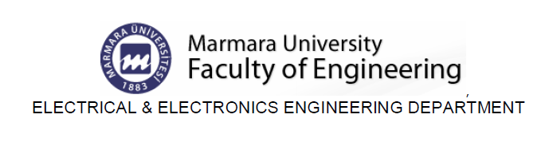

EE312 Exp. #3
OP-AMP
Report #3

COURSE LECTURER:
Assistant Professor Dr. M.A.Alsunaidi
LABORATORY INSTRUCTOR:
Research Assistant Dr. Deniz Özenli
Prepared by
Name:
Surname:
#ID:
CAUTIONARY REMARK: All questions will be answered in the assigned blanks. Don’t use extra place for the answers due to the fact that they are not guaranteed to be evaluated.
Part 1--Introduction: Explain the main objective of the experiment on your own words. (10pt)

Part 2--Procedure: a) Op-Amp: Reseach the meanings of slew rate, input offset current and voltage , input range and output range, DC gain. Explain in your own words. (25pt)

b) Compare your measurement results during the lab with LM-741 datasheet values. If there are pretty much difference, explain main sources of the discrepancies. (20pts)

c) Research the concepts of folded cascode, telescopic cascode and rail to rail opamps. Give an exemplary circuit for anyone. Find the AC gain and cut-off frequency of this circuit. (30 pts)

Part-4--Conclusion: Conclude your report with your learning from this experiment on your own words. Moreover, you can discuss or criticize some over-expected or under-expected sides of the experiment. (20pt)

Part-5--References: If you have referred parts, specify their references below. (10pt)

