EE312 Exp. #4
FEEDBACK
Report #4

COURSE LECTURER:
Assistant Professor Dr. M.A.Alsunaidi
LABORATORY INSTRUCTOR:
Research Assistant Dr. DenizÖzenli
Prepared by
Name:
Surname:
#ID:
CAUTIONARY REMARK: All questions will be answered in the assigned blanks. Don’t use extra place for the answers due to the fact that they are not guaranteed to be evaluated.
Part 1--Introduction: Explain the main objective of the experiment on your own words. (5pt)

Part 2--Procedure: a) Feedback: Mention negative feedback’s advantages and drawbacks. Which criterion is it required to keep your circuit from oscillation? Explain (10pt)

b) Consider Figure 1 below. For these values, calculate β, A_{vf}, R_{if}, R_{of} values. Specify your feedback type with reasons. Compare these values with your measurement results during the lab. Comment on results. (20pt) Hint: Use low frequency h-parameter model. Take R₂ as 4k7Ω.
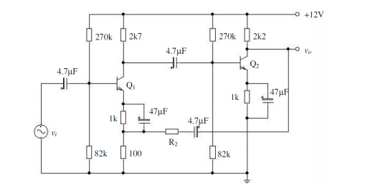
Figure. 1

c) Calculating corner frequencies: Calculate f_{L} and f_{H} of the given circuit in Figure.1 above. Compare theoretical results with your measured values during the lab. Comment on the comparison if there are some differences. (15pt)

Part-3—LT-Spice Simulation Part: Construct Figure.1 in the LT-Spice and utilizing BC 237 BJT model in the Appendix. a) DC Analysis: Give DC op. points. (10pt)

b) AC Analysis: Plot AC gain of the circuit and specify the cut-off frequencies. Compare them with your measured values during the lab. Comment on results.(15pt)

c) Z_{in} and Z_{out} measuring: Plot Z_{in}and Z_{out} in the frequency domain. (10pt)

Part-4--Conclusion: Conclude your report with your learning from this experiment on your own words. Moreover, you can discuss or criticize some over-expected or under-expected sides of the experiment. (10pt)

Part-5--References: If you have referred parts, specify their references below. (5pt)

Appendix:
BC237 BJT Model Parameters for Spice Simulation:
.MODEL BC237 NPN (IS=1.8E-14, ISE=5.0E-14, NF=0.9955, NE=1.46, BF=400, BR=35.5, IKF=0.14, IKR=0.03, ISC=1.72E-13, NC=1.27, NR=1.005, RB=0.56, RE=0.6, RC=0.25, VAF=80, VAR=12.5, CJE=13E-12, TF=0.64E-9, CJC=4E-12, TR=50.72E-9, VJC=0.54, MJC=0.33)

