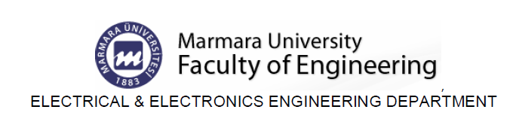

EE232Exp. #2
Diode Characteristics
Report #2

COURSE LECTURER:
Associate Professor Dr. Emre Arslan
LABORATORY INSTRUCTOR:
Research Assistant Deniz Özenli
Prepared by
Name:
Surname:
#ID:
CAUTIONARY REMARK: All questions will be answered in the assigned blanks. Don’t use extra place for the answers due to the fact that they are not guaranteed to be evaluated.
Part 1--Introduction: Explain the main objective of the first experiment on your own words. (10pt)

Part 2--Procedure: a) Conventional Diode Basics: Describe $R_{DC}$ and $r_{AC}$ of conventional diode in mathematical expression. Comment on the meaning of those. (10pt)

b) Solve the following circuit using linear diode model. Take as ${ r}_{d}=30Ω$ , $V_{on}=0.7V, R_{1}=1k and V_{S1}=8V$ (10pt)
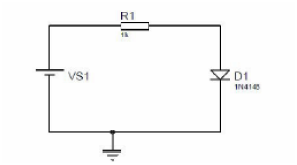

c) Plot $V_{R}$ versus $V_{D}$and $V_{D}$ versus $I_{D}$ using your measurements during the lab by considering the following circuit. (20pt)

d) Solve the following circuit using zener diode equivalent model. Take as ${ r}_{z}=15Ω$ , $V_{Z}=6V, R_{1}=1M and V_{S1}=-8V$ (10pt)

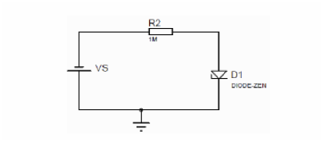

e) Plot forward and reverse bias results together using your measurements during the lab by considering the following circuit. (20pt)

Part-3--Conclusion: Conclude your report with your learning from this experiment on your own words. Moreover, you can discuss or criticize some over-expected or under-expected sides of the experiment. (10pt)

Part-4--References: If you have referred parts, specify their references below. (10pt)

