**MATH 171 MIDTERM EXAM 29/03/2012**

**Name: Student ID # :**

|  |  |  |  |  |  |  |
| --- | --- | --- | --- | --- | --- | --- |
| **Q1 (10)** | **Q2(15)** | **Q3(15)** | **Q4(20)** | **Q5(20)** | **Q6(20)** | **Total (100)** |
|  |  |  |  |  |  |  |

**ATTENTION: There are 6 questions on 4 pages. Solve all of them. Duration is ONE hour.**

**1-** (10) Solve the following inequality



**Solution:**

$-3≤\frac{5x-6}{13}≤3$

$-39≤5x-6≤39$

$-33≤5x≤45$

$$-\frac{33}{5}≤x≤9$$

**2-** (15) Solve the following equation for *x*:



**Solution:**



Only  satisfies ()

**3-**(15) The Davis company manufactures a product that has a selling price of $20 and a unit cost of $15. If fixed costs are $600,000, determine the least number of units that must be sold for the company to have a profit.

**Solution:** Let q be the number of units that must be sold. Then variable cost is  and so the total cost is . The total revenue is . Since we want to profit > 0, we have

total revenue-total cost > 0



So, the least number of units that must be sold is 

**4-**(20) Two lines passing through (3,2). a) One is parallel to the line  and b) the other perpendicular to it. Find equations of these lines. (do not sketch it)

**Solution:** a) line parallel to  also has slope -2 (). Using point-slope form we get

 or



b)Slope of perpendicular line to  must be . Using point-slope form we get







**5-**(20) For the equation , (a) find the intercepts, (b) find the vertex, (c) state the domain and the range (d) and then sketch it.

**Solution:**

 or 

 











*Domain*: -

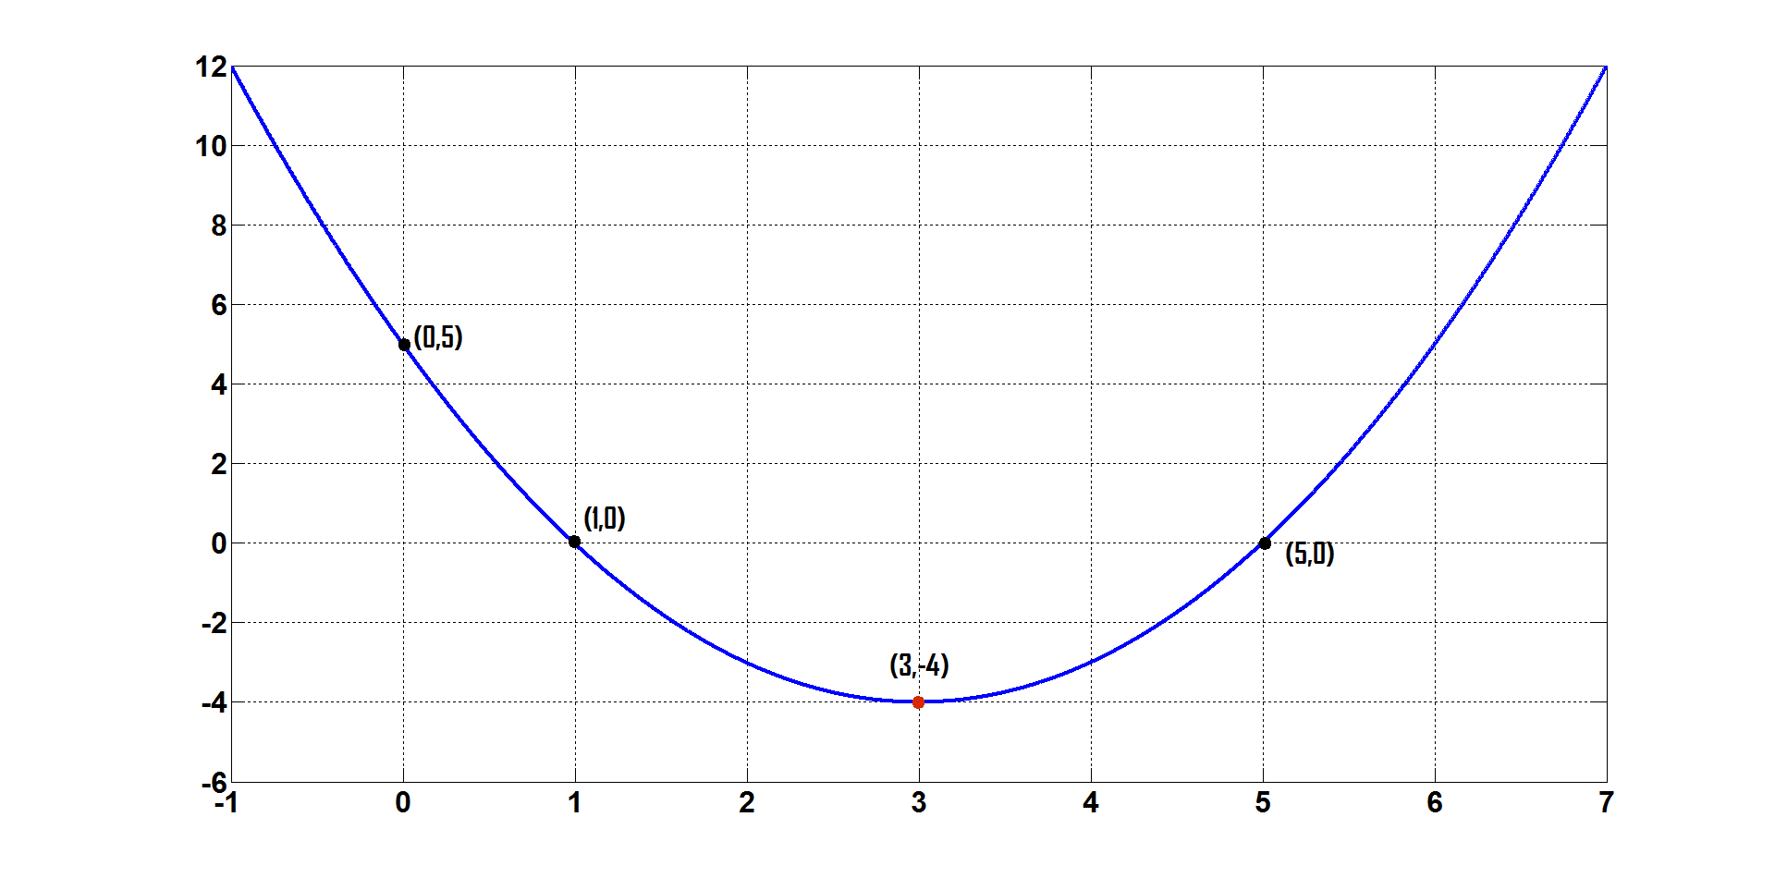

**6-** a) (10) Find the present value of 2000TL due after four years if the interest rate is 12% compounded monthly? (Use table if necessary)

b) (10) How long will it take for 1000TL to amount to 2000TL at an annual rate 8% compounded quarterly? (Use table if necessary)

Table

|  |  |  |  |
| --- | --- | --- | --- |
|  |  |  |  |
|  |  |  |  |

**Solution:** a) Present value :  where

 TL; . and . Then the present value is given by





**Solution:** b) Compound amount :  where

,  TL and the periodic rate . The number of interest periods is found as



 or 

The number of years is then given by 